SIMATS ENGINEERING (SAVEETHA SCHOOL OF ENGINEERING)
Department of Artificial Intelligence and Data Science
ASSESSMENT TOOL 1 – Experiments

Course Code: | DSA0301 | Course Title: | Natural Language Processing
CO Assessed: | CO3 – Precision | Assessment: | Assessment Tool 1 – Experiments
Weightage: | 50% of CIA
CO5 Statement: | Apply N-gram models, smoothing techniques, part-of-speech tagging systems and to evaluate effective syntactic analysis. (BL-3)
Student Name: | P. Sai Bhavyatha | Reg. No.: | 192424333
Section / Batch: | AI & DS /2024 | Date: | 17-08-2026

Code of Conduct
I P. Sai Bhavyatha(192424333) (Name / Reg No) certify that this submission is my original work and that I have adhered to the guidelines specified for this assessment. I understand that any violation of academic integrity rules will result in disciplinary action.
Signature of the Student: Palacharla Sai Bhavyatha

Instructions
- Perform all experiments using Google Colab.
- Create a separate notebook (.ipynb) for the assessment.
- Ensure all code is executable without errors.
- Include appropriate comments explaining the logic used.
- Complete all three experiments in a single Google Colab notebook.
- Execute all cells and display the outputs for the given test cases.
- Save the notebook with the naming convention: RegNo_Name_CO3-AT1.ipynb
- Upload the notebook to your GitHub repository.
- Ensure the repository is public or accessible to the instructor.
- Submit the following:
- GitHub Repository Link in GCR
- Google Colab Share Link in GCR
- Screenshots of uploaded coding and output files as printout.
- Duration: 30 minutes.

Section / Topic | Focus |  | Experiment Questions
Context-Free Grammars for English Syntax, Context-Free Rules and Trees, Sentence-Level Constructions, Parsing, Top-Down Parsing, Earley Parsing |  | Design a Python program to validate sentences using CFG production rules and construct parse tree representations for valid sentences. | Q1
Agreement, Feature Structures, Sub Categorization |  | Design a Python program to verify subject–verb agreement and validate grammatical constraints using feature structures and subcategorization rules. | Q2
Probabilistic Context-Free Grammars (PCFGs) |  | Design a Python program to parse sentences and compute sentence probabilities using probabilistic grammar production rules. | Q3

Annexure A – Experiments

Experiment 1: Context-Free Grammar Rule Validation and Parse Tree Construction

Experiment Description
Design a Python program to validate whether a sentence follows the given Context-Free Grammar (CFG) rules and generate its parse tree representation.
Grammar:
S → NP VP
NP → Det N
VP → V NP
Det → the | a
N → dog | cat | bone
V → chased | found

Task
- Accept a sentence as input.
- Verify whether it conforms to the CFG.
- Construct and return the parse tree.
- Return "Invalid Sentence" if parsing fails.

Function Prototype
def parse_cfg(sentence):
pass

Test Cases
Input | Expected Output
the dog chased a cat | Valid Parse Tree
a cat found the bone | Valid Parse Tree
dog chased cat | Invalid Sentence
the bone found a dog | Valid Parse Tree
chased the dog bone | Invalid Sentence

Experiment 2: Agreement and Feature Structure Checking

Experiment Description
Design a Python program that verifies subject–verb agreement using feature structures containing Number and Person attributes.

Feature Rules
he → singular, third person
she → singular, third person
it → singular, third person
we → plural
eats → singular verb
sleeps → singular verb
eat → plural verb
sleep → plural verb

Task
- Accept Subject and Verb.
- Compare feature structures.
- Return True if agreement holds.
- Return False otherwise.

Function Prototype
def check_agreement(subject, verb):
pass

Test Cases
Subject | Verb | Expected
he | eats | True
he | eat | False
we | eat | True
we | sleeps | False
she | sleeps | True

Experiment 3: Probabilistic Context-Free Grammar (PCFG) Parsing

Experiment Description
Implement a Python program to compute the probability of a sentence using the given PCFG.

Grammar
S → NP VP [1.0]
NP → Tom [0.7]
NP → Ann [0.3]
VP → sings [0.4]
VP → dances [0.6]

Probability Formula
P(Sentence)
=
P(S→NP VP)
× P(NP)
× P(VP)

Task
- Accept a two-word sentence.
- Parse using the PCFG.
- Compute sentence probability.
- Return 0 if sentence cannot be generated.

Function Prototype
def sentence_probability(sentence):
pass

Test Cases
Input Sentence | Expected Probability
Tom sings | 0.28
Tom dances | 0.42
Ann sings | 0.12
Ann dances | 0.18
Sam sings | 0.00

Experiment 1: Context-Free Grammar Rule Validation and Parse Tree Construction
Code & Output
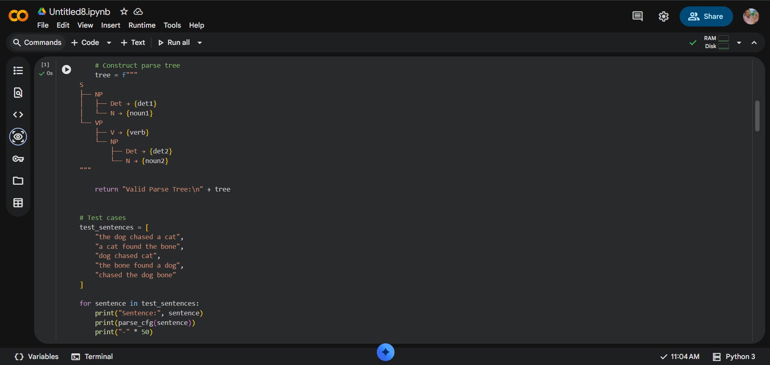
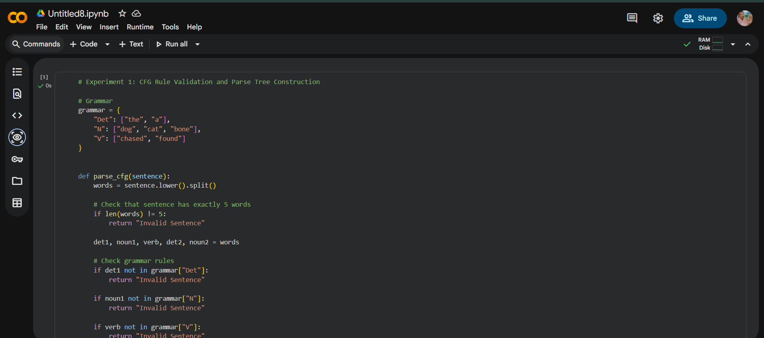

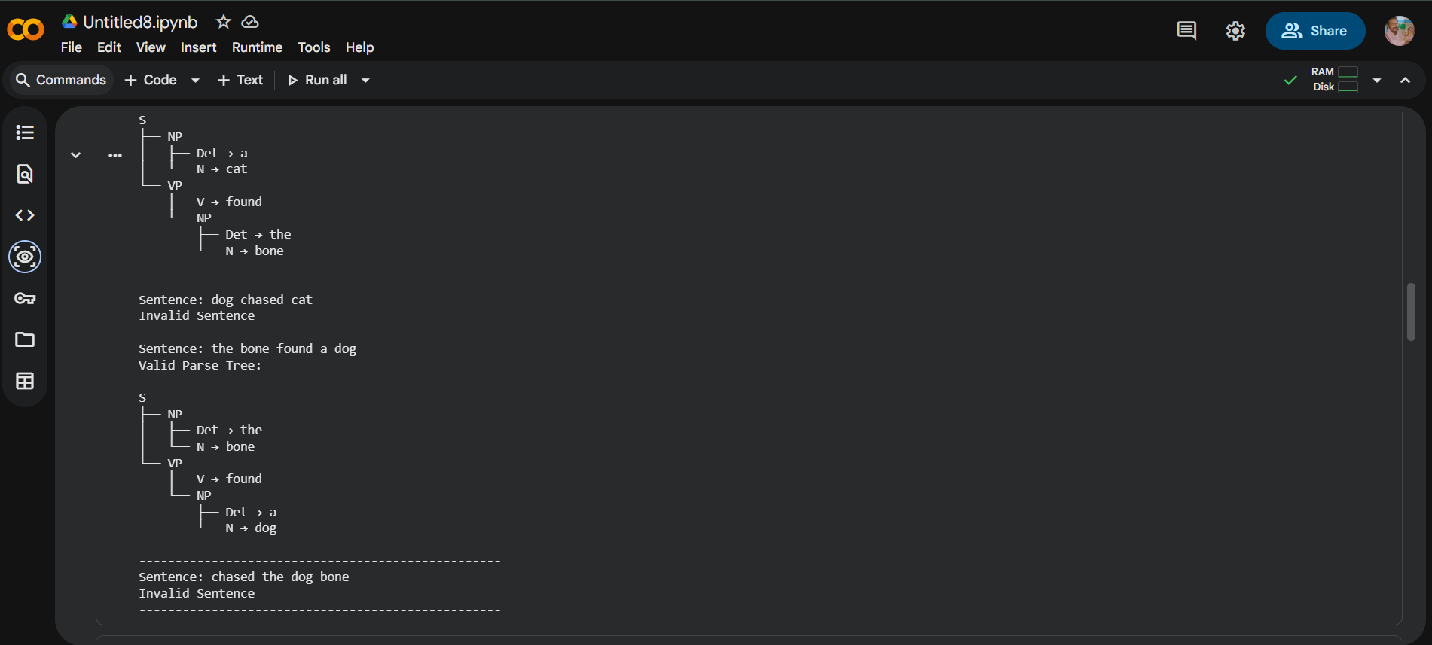
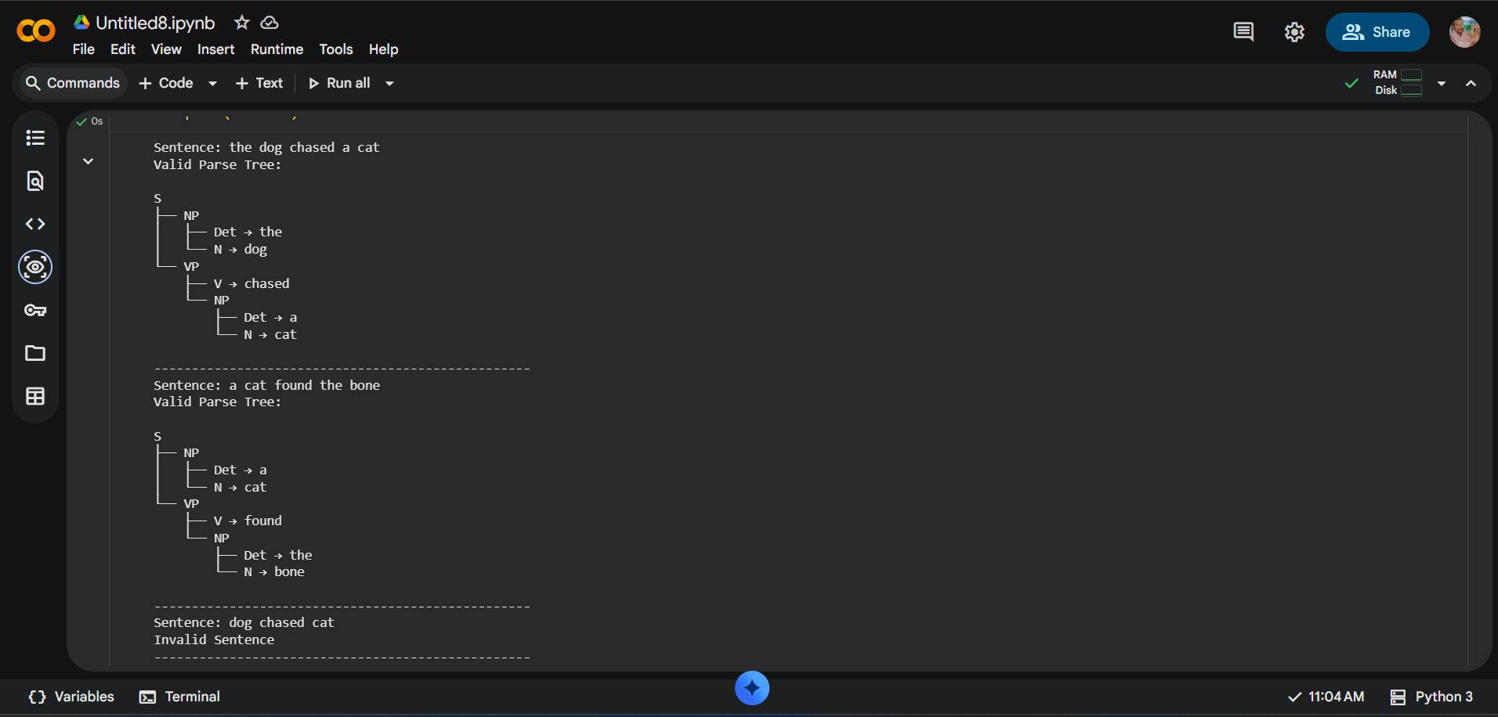

Experiment 2: Agreement and Feature Structure Checking
Code & Output:
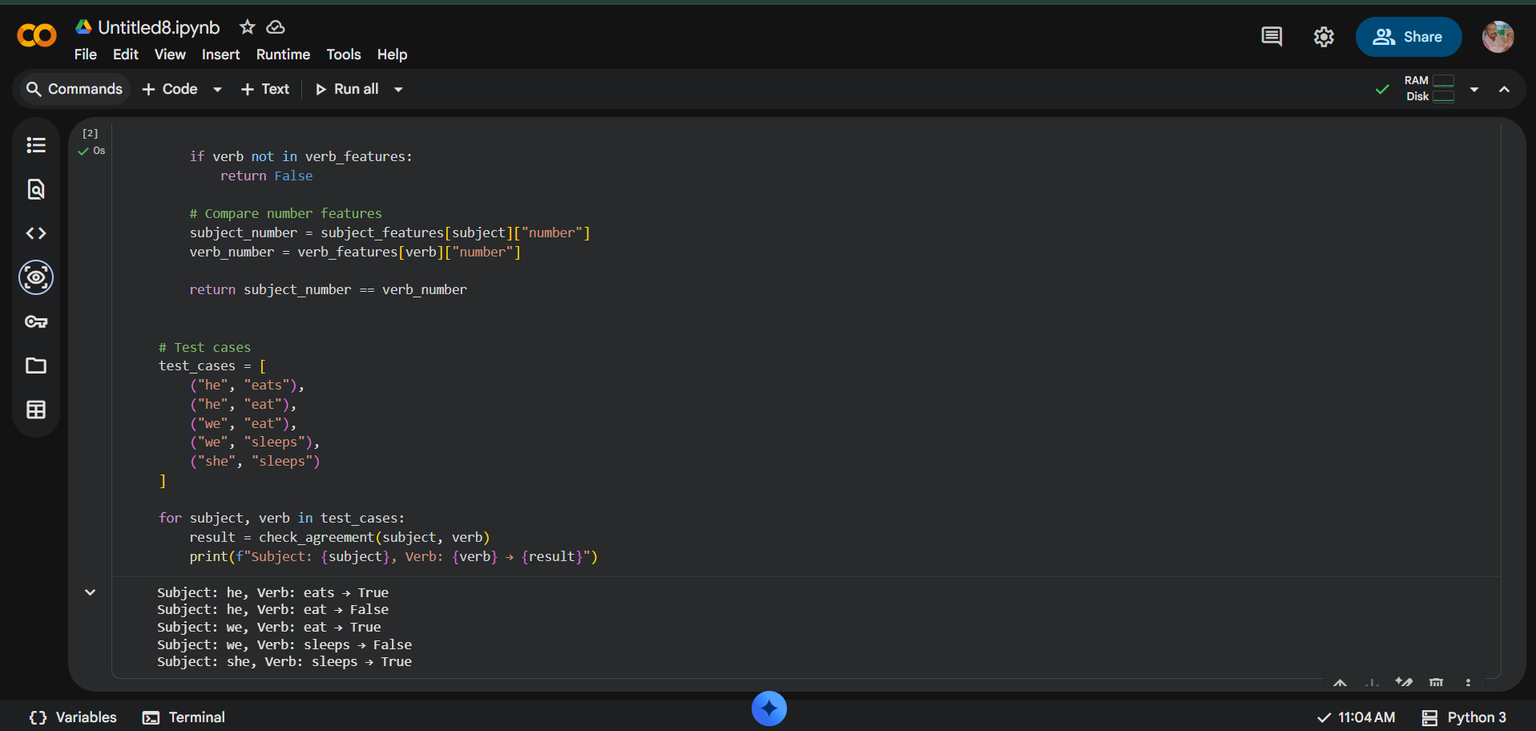
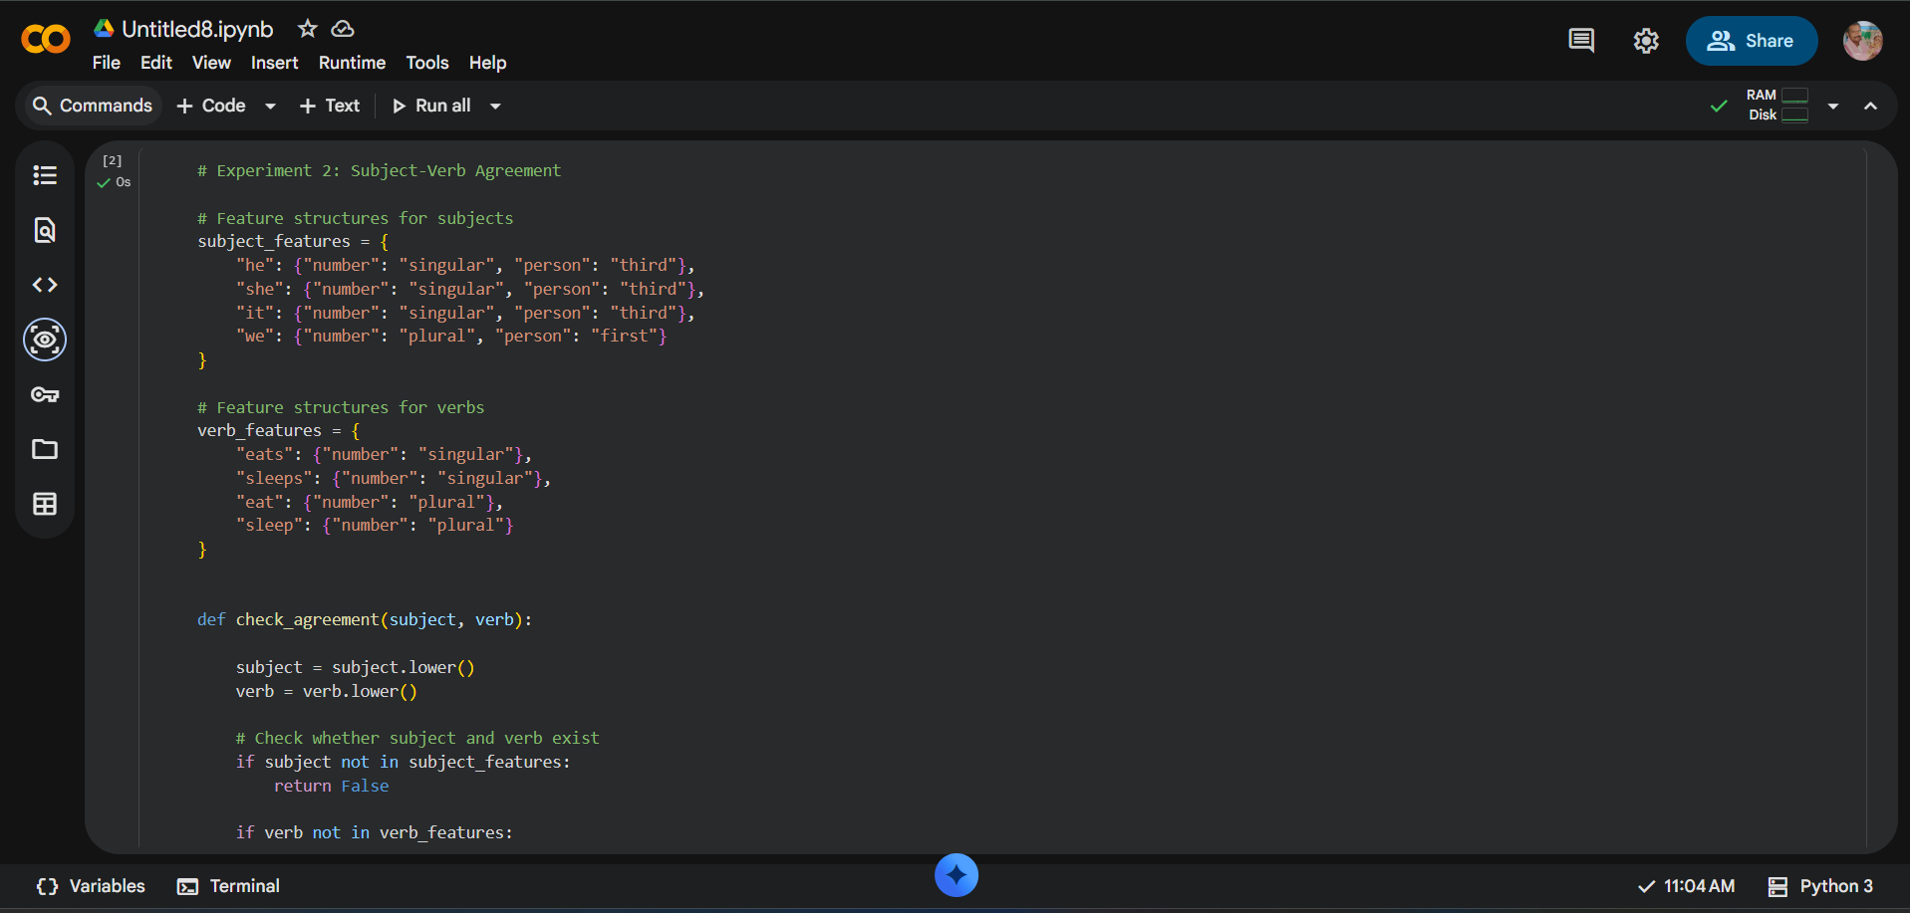

Experiment 3: Probabilistic Context-Free Grammar (PCFG) Parsing
Code & Output:
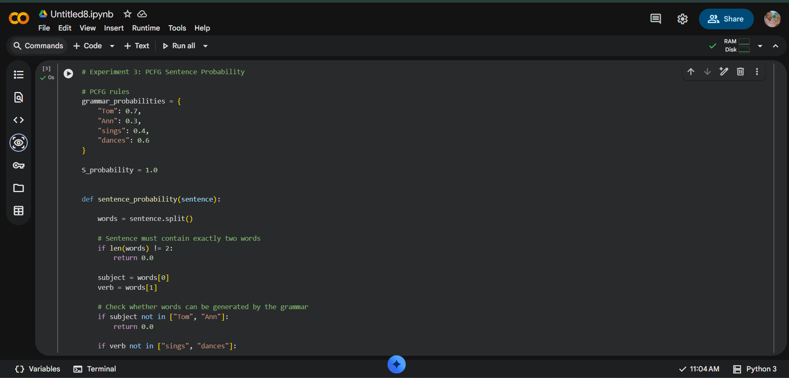
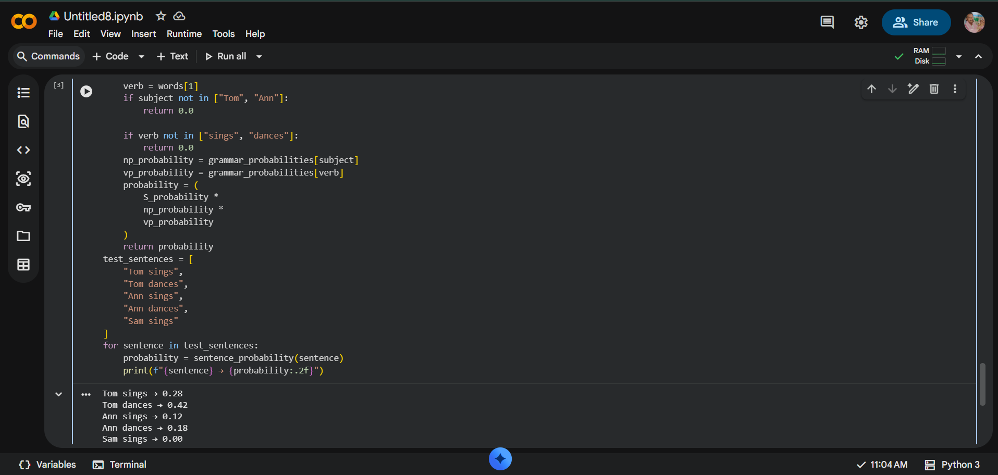

Rubrics for Calculation

Criteria | Weightage | Level 4 – Exemplary | Level 3 – Proficient | Level 2 – Developing | Level 1 – Beginning
Understanding of Concepts | 25 | Demonstrates thorough understanding and effectively integrates multiple concepts/technologies | Good understanding with proper integration of most concepts | Basic understanding; limited or partial integration | Poor understanding; unable to integrate concepts
Experimental Design | 30 | Well-planned, systematic implementation with optimal solution | Correct implementation with minor issues | Basic implementation with errors or inefficiencies | Incorrect or incomplete implementation
Use of Tools | 20 | Effective and advanced use of tools/technologies with proper configuration | Appropriate use of tools with correct execution | Limited or inconsistent use of tools | Incorrect or minimal use of tools
Analysis of Results | 15 | Insightful analysis with accurate interpretation and validation of results | Good analysis with reasonable interpretation | Basic analysis with limited insights | Poor or incorrect analysis of results
Documentation | 10 | Clear, well-structured documentation with diagrams, code, and results | Organized documentation with necessary details | Basic documentation with missing details | Poor or incomplete documentation

Q. No. / Criteria Level | Understanding of Concepts | Experimental Design | Use of Tools | Analysis of Results | Documentation | Sub. Total | Total %
1
2
3

Faculty In-charge | Course Coordinator | Program Director
Signature: _______________ | Signature: _______________ | Signature: _______________
Date: ___________________ | Date: ___________________ | Date: ___________________

